Bethel Prayers and Songs while We Are Sheltered in Place
In lieu of bulletins

Sunday After Easter
April 19, 2020

Bethel United Methodist Church seeks to be a church that fulfills the spiritual needs of the community, shows God’s love to all, and serves God in all it does.

April 19 Sunday after Easter Rev. John Holsey preaching

Opening Prayer
God of signs and wonders, breathe new life into us this day, that our spirits may awaken to the joy and the hope of our glorious inheritance through the living Christ. Clear our vision, Holy One, that we may see the promise of Easter in the stirrings of this precious earth and in the life energy flowing through our bodies. Help us find the faith to believe where we have not seen, that others may see, in our living and our loving, the glory of the risen Christ. Amen.

Hymn UMH #304 Easter People Raise Your voices

Prayer of Illumination Almighty God, in you are hidden all the treasures of wisdom and knowledge. Open our eyes that we may see the wonders of your Word; and give us grace that we may clearly understand and freely choose the way of your wisdom; through Christ our Lord. Amen.

Gospel Reading John 20.19-31

(Silent meditation)

Hymn UMH #308 Thine Be the Glory

Benediction
Through Christ, God has given us a new birth
into a living hope.
God has given us an inheritance
that is imperishable, undefiled, and unfading—
an inheritance protected by the power of God.
Rejoice, therefore, even if for a while
we suffer various trials.
For life is stronger than death,
love is stronger than hate,
joy is stronger than sorrow,
and the promises of God are sure.

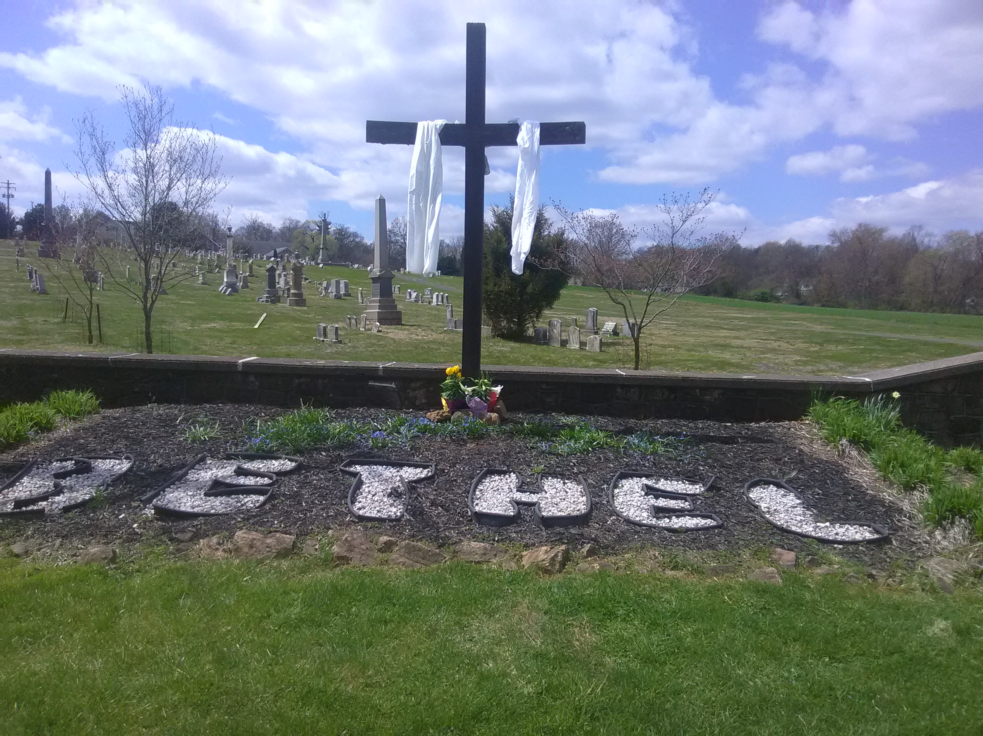

+++

Activity packets are available in a basket in the narthex for children to use during church services. Feel free to take your packet home with you.

Children Sunday School in the Education Wing after the Children’s Message.
Follow us at bethelspringcity on Instagram and bethelumchurch on Facebook

Welcome to Bethel United Methodist Church
“Growing in Christ together, sharing God’s love with everyone.”

Sunday After Easter
April 19, 2020

952 Bethel Church Road, Spring City, PA 19475
Web: bethelumchurch.com

Pastor Jacqueline Hines
H: 610-495-5070 C: 410-963-1721
Pastor’s Email: pastorjacquelineumc@gmail.com

Administrative Assistant: Samantha Stauffer
Office Phone 610-495-6807/610-495-8843
Church Email: betheloffice952@aol.com
Musician: James Matz Sextons: Chris and Paul Long
Bethel Christian Preschool
Director: Janet Hunter Phone: 610-412-7464
Preschool Email: bethelcp@verizon.net
Web: bethelchristianpreschool.org

